# User Manual

In this chapter, we provide a detailed description of how to be able to use our VQA android application.

We used a local host technique to host our python backend on the laptop, and then we make a communication between the Android interface and the python backend using Flask web framework.

1. **Create a network**

* make a network between your mobile and the laptop using possible two ways:
  1. **Wi-Fi connection**
     + Make your mobile and laptop connect on the same router.
  2. **mobile hotspot**
     + Open your mobile hotspot and connect on it using your laptop.

1. **Extract the network IP address**

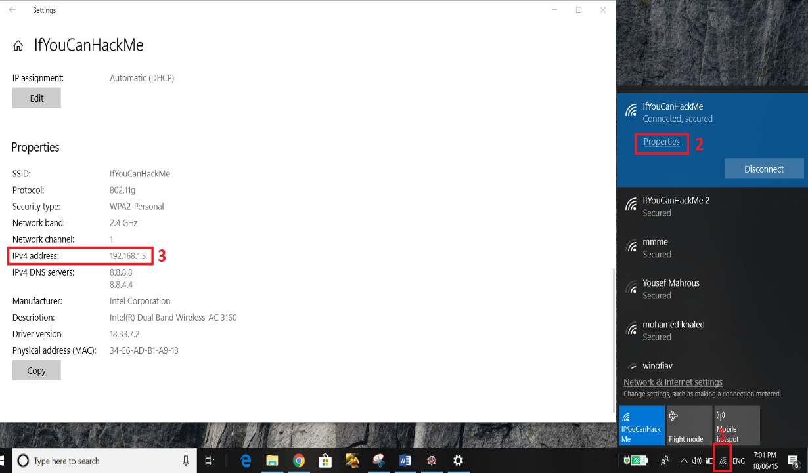

**Figure 29- Extract the network IP address**

1. Click on the Wi-Fi icon.
2. Open Wi-Fi properties.
3. Get Your IP address.
4. **Run the localhost**

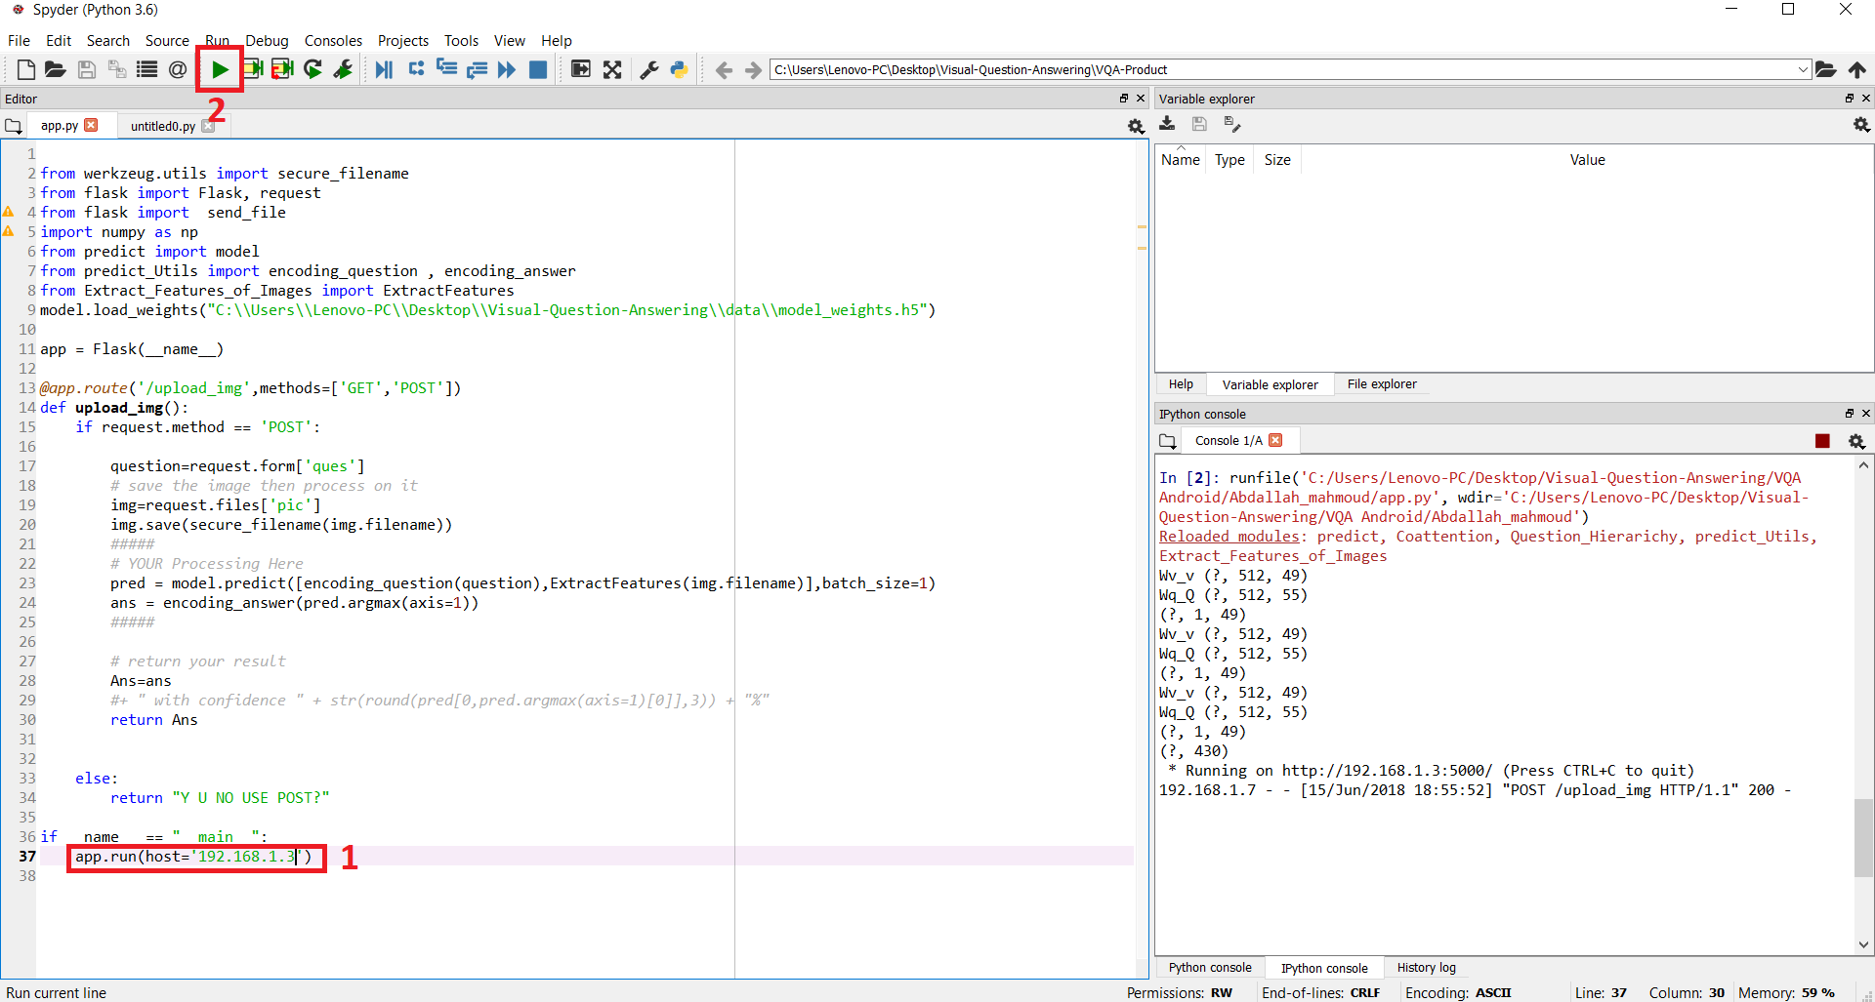

**Figure 30 - Run the localhost**

1. Put your network IP in this line of the code (**app.py**).
2. Run the **app.py** file.
3. **Run the android application**

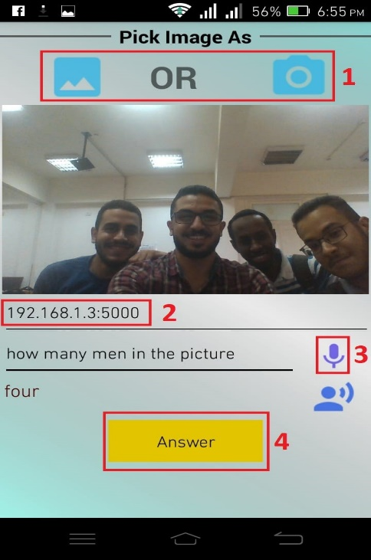

**Figure 31- Android app sample input**

1. Pick an image from your gallery or using your camera.
2. Put the network IP followed by “**:5000**” as shown in **Figure 31.**
3. Click on the microphone icon to pronounce your question or manually write it in the input textbox.
4. Click on “**Answer**” button to achieve the answer.